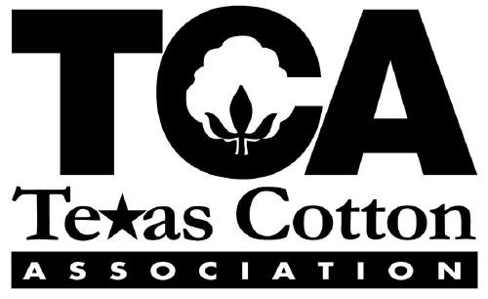

TCA President, Ellen Batchelder, of BUNGE, Palacios, Texas,
announces the theme of this year’s 115th Anniversary Convention,
“Deep Roots. Bold Growth: The Texas Cotton Association Legacy”.

Deep in the Heart of TEXAS, we celebrate one hundred and fifteen years
of The Texas Cotton Association
and the people's love of TEXAS COTTON.
Filled with grit and gumption, our storied history is the cornerstone for bold growth,
today, and for centuries to come.
That is our legacy. And it is our future.

The Texas Cotton Association extends a warm invitation to all U.S. cotton merchants, transportation and supplier partners, cotton association groups and their members, and families and friends! We have planned some profitable networking opportunities and productive meetings that are sure to make your trip worthwhile!
CONVENTION HOTEL: On April 28 – May 1, 2026, at the Texas A & M Hotel, the host of this year’s convention, you will find “HOWDY HOSPITALITY”, a AAA 4 Diamond facility located in the heart of the historic Texas A & M Campus and the famous Kyle Field at 177 Joe Routt Blvd., College Station, Texas, 77840, 979.260.2235 or 888.654.4436. The property is within two-to-three-hour drive of Houston, Austin, San Antonio and Dallas. Easterwood Airport is eight minutes away, offering connections to most U.S. cities and daily flights from Houston and Dallas!
TRAVEL PLANS: Under Convention 2026 in the header of our website at www.tca-cotton.org, you will find a TENTATIVE SCHEDULE to assist you in planning your travel. Please plan to arrive on Tuesday, April 28, if you are planning to play golf. We will gather for the SAM CLAY MEMORIAL CALCUTTA at 6:00 p.m., followed by the TCA DALCOT GOLF SCRAMBLE for an 8:00 a.m., SHOTGUN START Wednesday morning. In making your travel plans home, we anticipate the General Session to conclude by noon and the Executive Session to conclude by 1:00 p.m. The new board can expect to adjourn by 2:00 p.m., at the latest. If you are interested in coming in early and staying late in College Station, our rates are available two (2) days pre-convention and post-convention based upon availability. Use Easterwood Airport (CLL) and book American Airlines to get here quick!
ONLINE FORMS!
Under Convention 2026 you will find an online registration and sponsorship link, and a hotel reservation link to secure your room. A QTR CODE has been created to link to a secure form to make your annual donation to the TCA PAC Political Action Committee).
Disclosure: The Texas Ethics Commission requires that funds be made with personal cards or checks. Corporate donations are not allowed.
This solicitation is for personal donations from MEMBERS ONLY and / or their family members and does not include the solicitation of the non-member class prohibited by laws governing the Texas Ethics Commission.
As other pertinent Convention 2026 information becomes available, we will post under the banner on our website. Look who's Coming and Look Who's Sponsoring links will post under the same CONVENTION 2026 header two weeks prior to convention.

HOTEL RESERVATIONS: We encourage attendees to check-in on Tuesday night, April 28, 2026, to get a head-start on networking and prepare for the activities over the next three days! Rooms are available at a special TCA room rate of $176 for singles and $186 for doubles, and NO RESORT fees! The total rate is subject to a 15.75% hotel occupancy rate. Complimentary self-parking in the Gene Stallings Blvd., parking garage attached to the hotel (one car per room). Complimentary WIFI is available throughout the hotel including guestrooms, meeting spaces and public areas. Toggle over Convention 2026 in the header of our website for a link to secure your room!

ACTIVITIES & MEETINGS

TCA TRIATHLON 2026:
- 1st TCA Triathlon TCA DALCOT GOLF SCRAMBLE! Shotgun start at 8:00 a.m., on Wednesday, Briarcrest Golf Club, Bryan, Texas, April 29, 2026!
For requested teams email Brady Raindl, Golf Chair at braindl@ecomtrading.com.
- 2nd TCA Triathlon MARKET GUESS GAME! Play for FREE when including your market guess on the registration form! Cut-off to play is April 7th!
- 3rd TCA Triathlon PICKLEBALL! Play to COMPETE or just for FUN! We will meet in the lobby at 12:45 p.m., Thursday, April 30, 2026, and walk over to the courts at the TAMU recreational center.

The TCA Triathlon event winners in First, Second & Third place will be awarded during the awards ceremony during the General Session on Friday morning, May 1, 2026. Winners must be present to win!

TICKET PURCHASES:
Say "HOWDY" to WIN a brand new IPAD! Join the COTTON CLUB at $10 per membership for a chance to win a brand new IPAD and to help the TCA defray additional costs associated with creating another great meeting experience. Enter the HOWDY, GET ROWDY RAFFLE for more chances to win an IPAD! Buy 5 tickets for $25.00 and get one ticket for a FREE chance to win! Winners will be awarded during the awards ceremony on Friday, May 1st. Must be present to win!

A "BIG HOWDY" WELCOME PARTY will take place at the University Club - 11th floor of the TAMU Rudder Center with panoramic views of TAMU, to celebrate opening night of the convention, April 29, 2026!

POLICY MEETINGS: On Thursday morning, April 30, 2026, we will polish our current policy after the committees have been working in advance to formulate the best blueprint to bring forward for final adoption. YOU are welcome to attend any of the other policy meetings in session! We invite your expertise to join the conversation! Participate in the Texas cotton industry TRANSPORTATION POLICY SUMMIT! We anticipate many transportation providers to be in attendance during the Transportation Committee Meeting as we SUMMIT to better coordinate and communicate what we need from each other to flow cotton more orderly and efficiently. A COMMITTEE MEMBER REQUEST form for ACTIVE and ASSOCIATE members will be generated in the next few days for you to add your name to a committee of your preference.

TRANSPORTATION RECEPTION: The annual reunion of transportation suppliers and merchants, a long-standing TCA tradition, will gather to socialize and form better business partnerships Thursday night, April 30, 2026, prior to the dinner and dance.

BATCHELDER PRESIDENTIAL DINNER DANCE: featuring entertainment by TEXAS UNLIMITED BAND a George Strait front band with an unlimited playlist of songs and notable performances at national rodeos, festivals, ...AND, the KNOT gives them a 5-star rating! Secure your table and place on the dance floor for this memorable event on Thursday night, April 30, 2026!

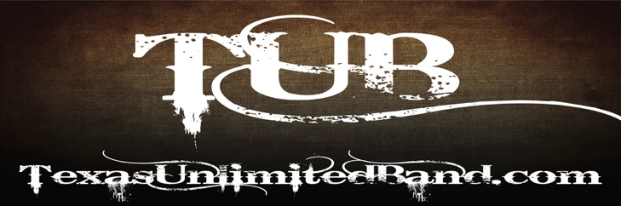
GENERAL SESSION: On Friday, May 1, 2026, during the General Session, The TCA Presidential Address will be given by ELLEN BATCHELDER, TCA PRESIDENT, followed by an ACSA update by ACSA CEO and PRESIDENT, WILLIAM H. (BUDDY) ALLEN. We have invited a Keynote speaker this year and we will advise you once the invitation has been accepted. We will advise updates to our program as more information is forthcoming.
The IPAD drawings and the winners of the TRIATHLON AWARDS, featuring the COTTON CUP presented to the top TRIATHLON performer, will follow.

EXECUTIVE SESSION: For Merchant & Primary Marketing members only, an Executive Session will meet immediately following to install the new president, elect the new board of directors and adopt policy resolutions. It is imperative if you are a voting merchant or primary marketing member that you make travel plans to attend or designate at least one from your firm to be present to adopt new policy and/or make changes to the By-Laws.

The success of our association and convention each year depends on YOU – our faithful attendees and sponsors! We hope that YOU will commit to attending this year's convention at the TEXAS A & M Hotel in College Station, Texas. We are filling advertising spots and have included some new ones - we encourage you to go check out the sponsorship package NOW! Please call 214.537.5330 and talk to Kandi Poteet or email her at tca@tca-cotton.org about sponsoring events or activities! We want to know if there is anything that we can do to improve your return on investment during our meetings and your relationship with TCA and our members. We thank you in advance for your interest in TEXAS COTTON and in The Texas Cotton Association!

REGISTER! SPONSOR! MAKE YOUR HOTEL RESERVATIONS! PICK UP A TENTATIVE SCHEDULE! Check out the header on this site for links to everything you need to join us at the TEXAS A & M Hotel, April 29, 30 & May 1, 2026!

Lastly...ATTIRE: We hope you know by now to WEAR YOUR COTTON BEST! See YOU in 100% COTTON in College Station!

